**Basic Python Lab Tasks**

**Introduction**

This lab is designed to develop the understanding of students with python input and arithmetic

operations along with the use of variables and making use of the conditional statements ,loops and functions.

**Objectives**

In this lab the students will learn about the basic concepts of python.

**Tools/Software Requirement:**

* Jupyter Notebook (Python)
* Google Colab Notebook (Python)

Write a program that asks the user to enter two numbers, obtains the two numbers from the user and prints the sum, product, difference, quotient and remainder of the two numbers.

Sample output is as following:

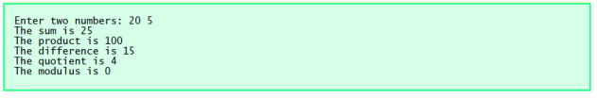

Write a program that reads in the radius of a circle and prints the circle’s diameter,

circumference and area. Use the constant value 3.14159 for π. Perform each of these

calculations inside the print statement(s).

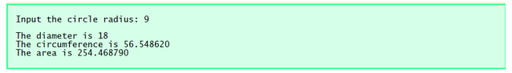

* Write a program that reads an integer and determines and prints whether it is odd or even.
* Write a program that inputs three different integers from the keyboard, and then prints the smallest and the largest of these numbers. Use only the single-selection form of the if statement that you learned in the class. The screen dialogue should appear as follows:

Input three different integers: 13 27 14

Smallest is 13

Largest is 27

* Write a program that reads three nonzero integers and determines and prints if they could be the sides of a right triangle. (Hint : use Pythagoras theorem you learned in mathematics during FSC or matric , try different combinations of the same integers )

Enter three integers: 3 4 5

The three integers are the sides of a right triangle

Enter three integers: 9 4 1

The three integers are not the sides of a right triangle

* Write a program to prompt for a score between 0.0 and 1.0. If the score is out of range, print an error message. If the score is between 0.0 and 1.0, print a grade using the following table:

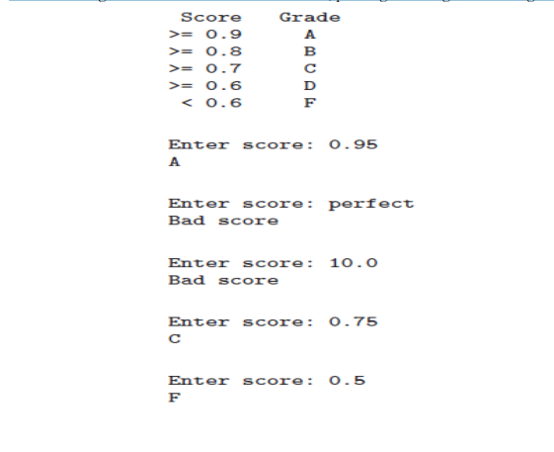

* Write a program that asks the user about the number of values he/she wants to enter. Than

enter the values as per the required number, calculate its sum and identify the smallest value among

them. The sample output is as follow:

Enter the number of values to be input: 5

Enter the number: 20

Enter the number: 10

Enter the number: 50

Enter the number: 4

Enter the number: 65

The sum is: 149

The smallest value of entered numbers is 4

* The greatest common divisor (GCD) of two integers is the largest integer that evenly divides each of the two numbers. Write function gcd that returns the greatest common divisor of integers. Hint(Use the gcd function in your program to determine the GCD of the numbers in the sample output:

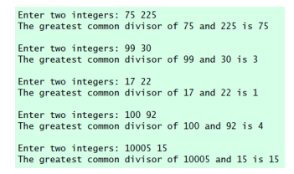

* Write a program that asks the user for their name and how many times to print it. The

program should print out the user’s name the specified number of times.

* Define a function called hypotenuse that calculates the length of the hypotenuse of a

right triangle when the other two sides are given. Use this function in a program to determine the length of the hypotenuse for each of the following triangles. The function should take two

arguments of float type and return the hypotenuse as float type too. The sample output is as

following:

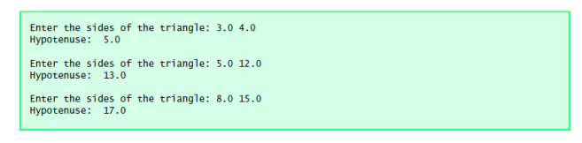

* Write a function is_prime that accepts an integer as argument and returns True if the number is prime and False otherwise. Use this function in your program to print on screen all the 4 digit prime numbers.
* An integer number is said to be a perfect number if its factors, including 1 (but not the

number itself), sum to the number. For example, 6 is a perfect number because 6 = 1 + 2+ 3.

Write a function perfect that determines if the parameter number is a perfect number

or not. The function should take an integer argument and returns Boolean True if the

integer is perfect and Boolean False otherwise.

Use this function in a program that determines and prints all the perfect numbers between

1 and 1000.